LeeWayne Barrineau

11/2/2019

Wild Wood Apartments SQL

1. 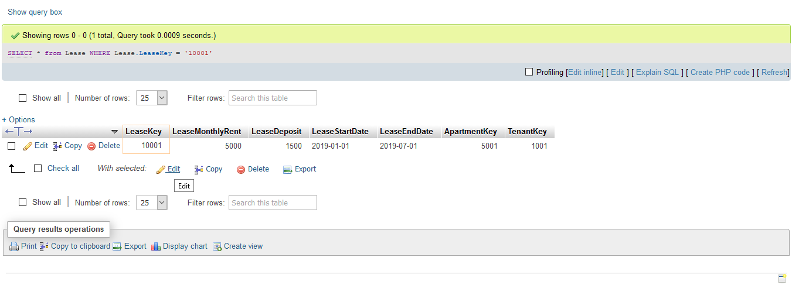Above is a basic where to entries of the lease key 10001.
2. 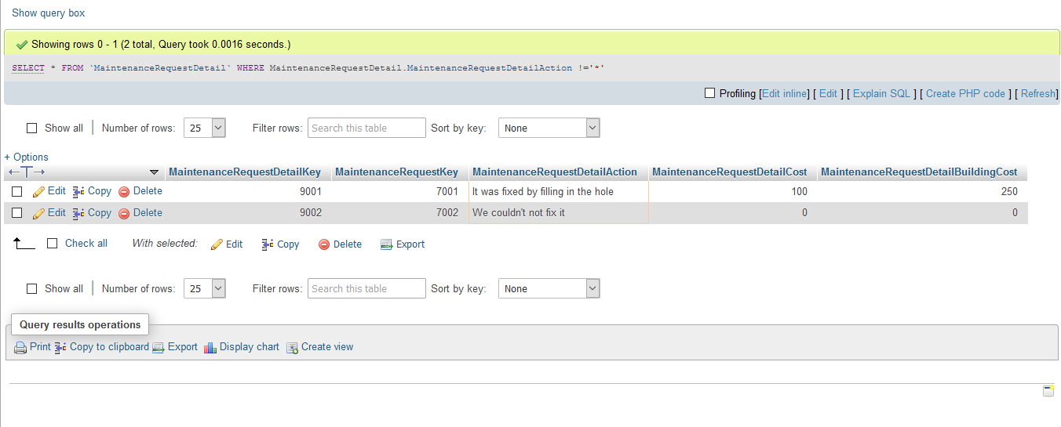

Above is a basic where to find all maintenance request that does not equal the star symbol.

1. 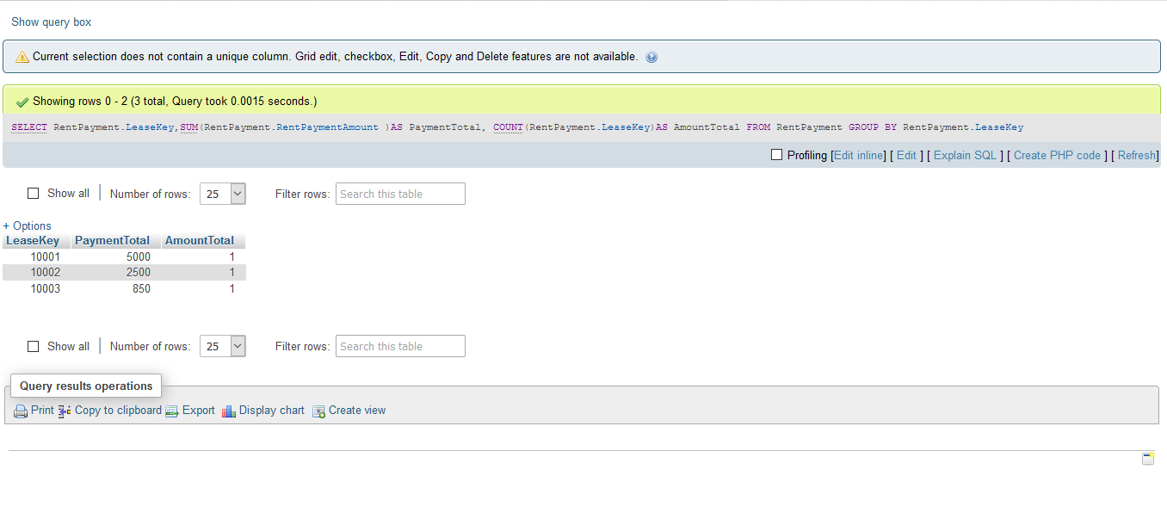

Above is a query to find the how many payments there was for each lease key.

1. 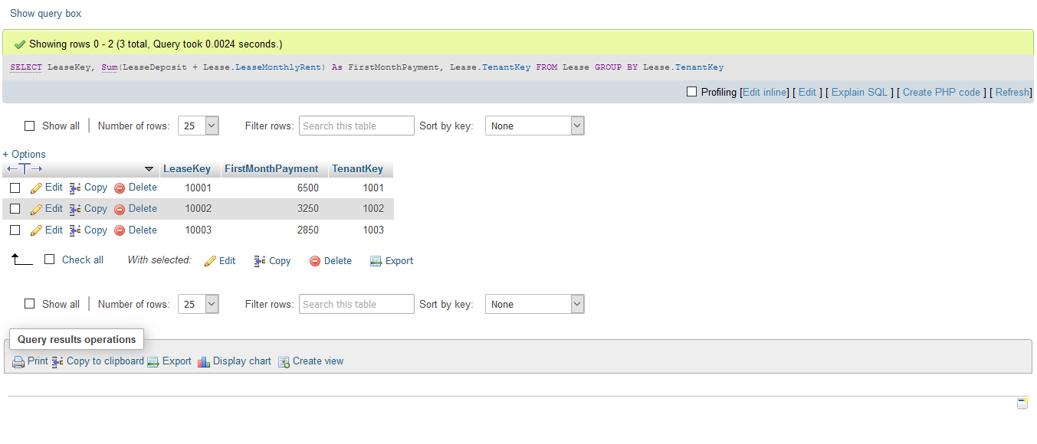

Above is a query that show the first month payment, this includes first month rent and deposit, for each lease and each tenant.

1. 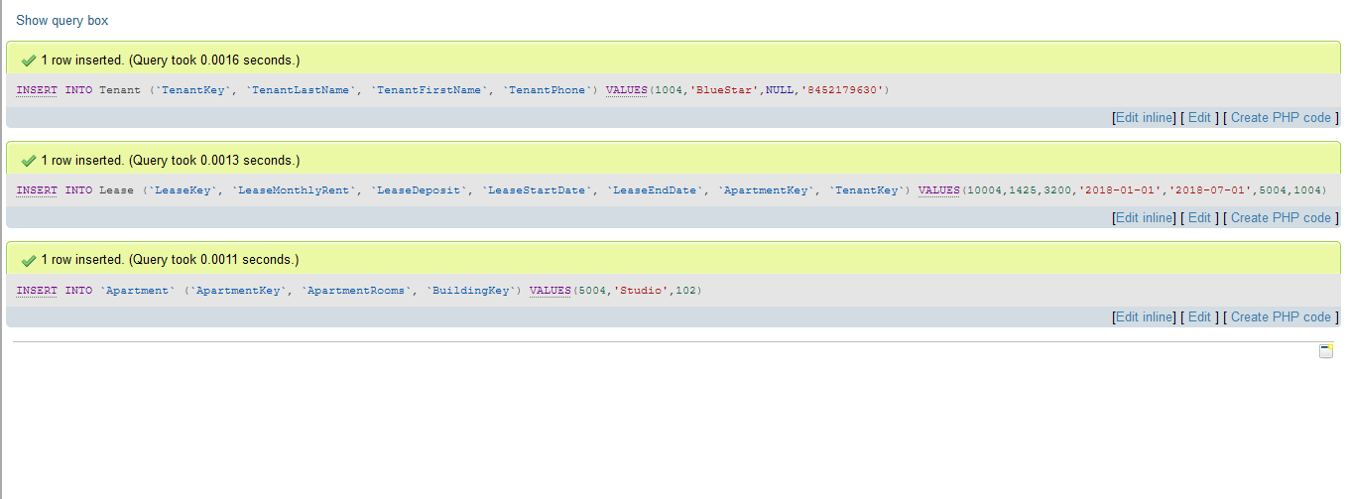Above is a picture of a new tenant, lease and apartment entries.
2. 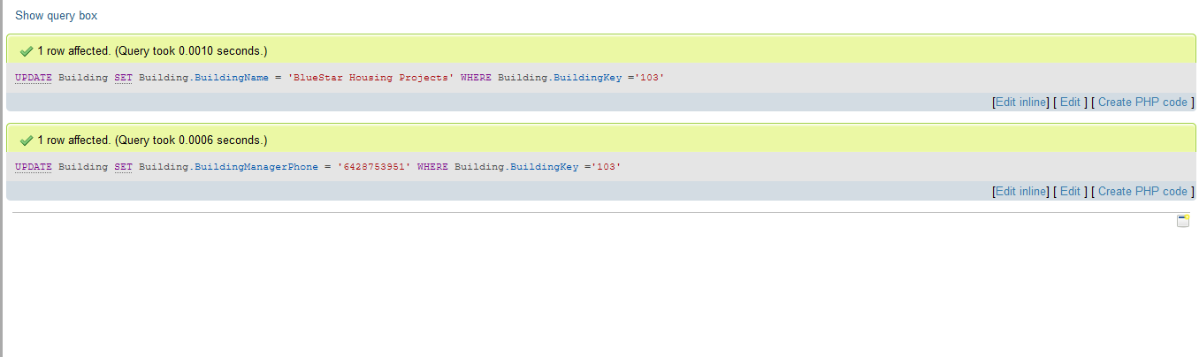Above is a picture of changing Red Hatter’s Apartments name and phone number to the one above
3. 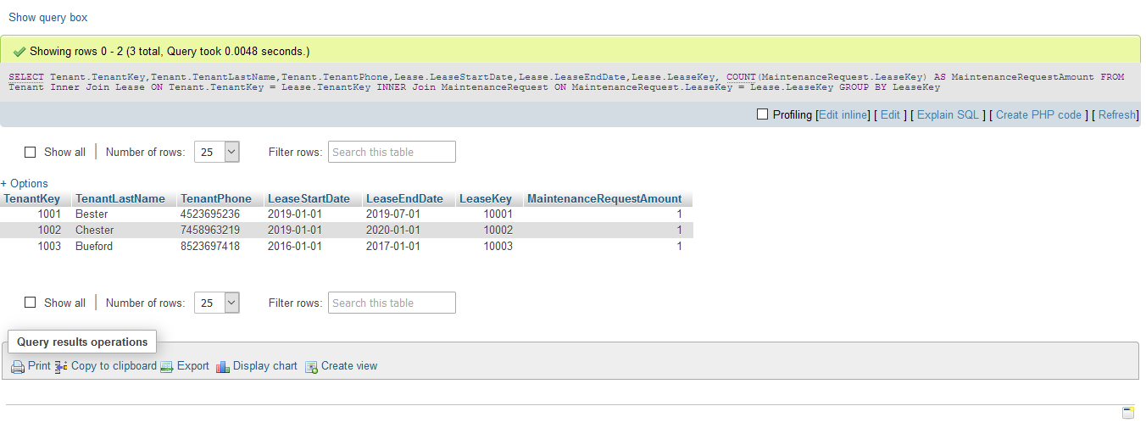Above is a picture of join done with the Wild Wood Apartments Database.
4. 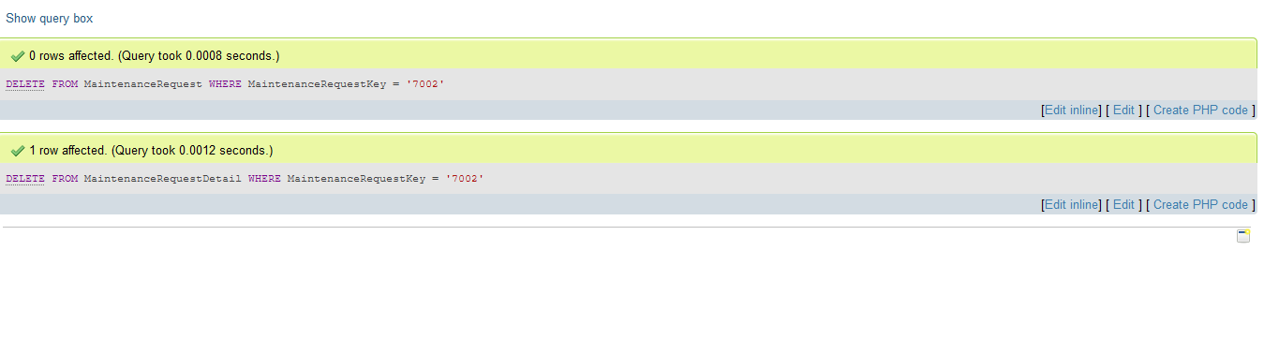Deletion of maintenance request 7002 from both maintenance request and maintenance request details tables.
5. 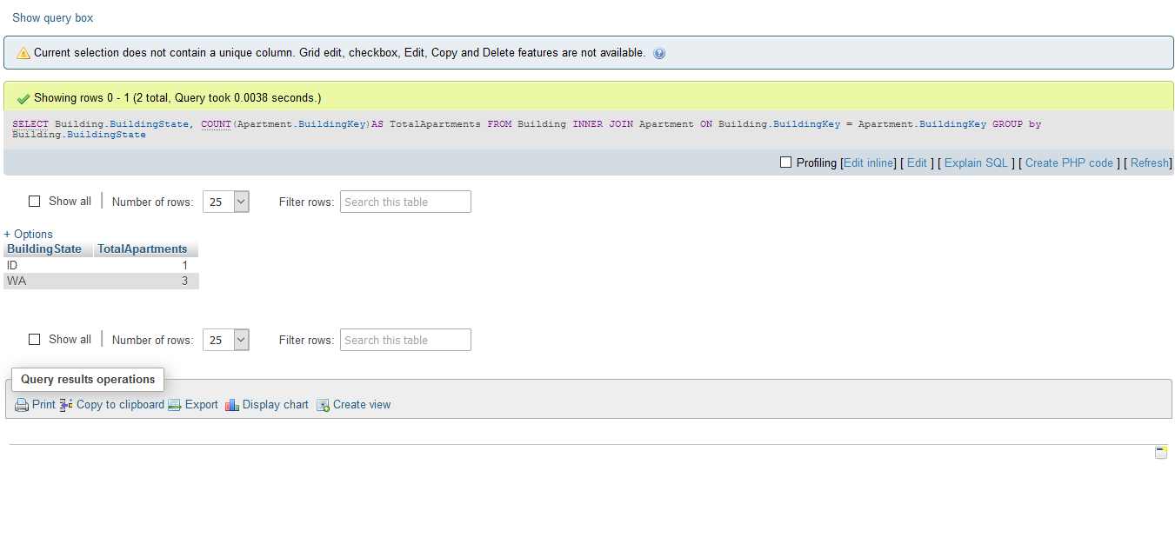Above is a join of Building and Apartment showing how many apartments are in each state.